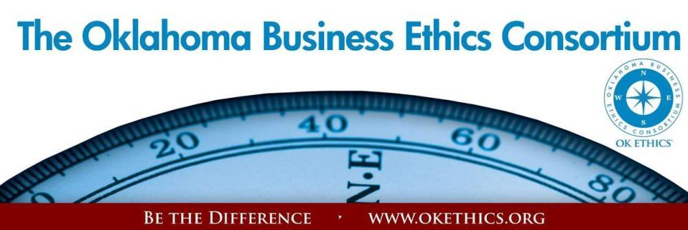

ENTERING OUR TENTH YEAR OF PROMOTING OKLAHOMA VALUES OF INTEGRITY AT WORK!
Agenda – February 13, 2013
- Welcome – Bob Byrne, Chief Diplomat, OK Ethics Board of Directors (Boeing – Retired)
- New members:

- OKC Leading: Oklahoma Sports & Orthopedics Institute
- OKC & Tulsa (shared) Leading: Mazzio’s
- Tulsa Leading: Samson Resources Company
- Tulsa Horizon: Cherokee Nation Businesses (Upgrade)

- OKC Frontier Member: Integris Health
- Tulsa Frontier Member: St. Gregory’s University
- Scout members: Paul Moore – Boy Scouts of America; Brand Bank (Tulsa); James Bissett – Continental Wire Cloth (Tulsa); Keith Jossell ; Dr. Don Hull – Oklahoma Christian University; Elizabeth Sharrock - Pierce Couch Hendrickson Baysinger & Green, LLP; Richard Dunn, CPA (Tulsa); V. Michael Hedrick, CPA
ATTENTION MEMBERS: RECRUITING GOALS FOR FY12-13 – PLEASE HELP OK ETHICS FLOURISH!
- 6 NEW LEADING MEMBERS - $1500 LEVEL – Only 3 more to go!
- 10 NEW FRONTIER MEMBERS - $400 LEVEL – Only 6 more to go!
- 10 NEW (OKC) SCOUT MEMBERS - $75 LEVEL – Only 5 more to go!
Did you know that 501c3, non-profit organizations can join for free at the Frontier level?
- Announcements: Accepting Nominations for Ethics Awards! Participate in the workshop!
Garyl Geist, Chief Operating Officer, Oklahoma Allergy & Asthma Clinic;
President, OK Ethics Consortium State Board of Directors

The purpose of these awards is to recognize businesses that are positively impacting their communities in ways that inspire integrity. There are two categories for this award: those having a positive influence on school campuses or those that impact the community as a whole.  See “Awards” Tab at www.okethics.org  for more information! | This award is based on Malcolm Baldrige Quality Criteria and is intended to:
  • | Share best practices
  • | Inspire trust of consumers and shareholders
  • | Build on solid reputation of business
  • | Improve quality of ethics initiatives
  • | Encourage others – including employees and vendors
- Volunteer Appreciation
OK Ethics relies primarily on volunteers to achieve the organization’s successful pursuit of Oklahoma’s values of integrity at work. It takes leadership and teamwork to host these exciting events and we salute your dedication in achieving OK Ethics’ mission! Listed below are today’s volunteers who consistently provide service to our members:

Agendas: Many thanks to the volunteers from Metro Technology Centers who provide our monthly agendas.

Ambassador Team: These friendly people welcome our guests each month and assist in helping them locate seats. They also arrive early to help distribute agendas and assist with name tags.
Linda | Streun | Ideal Homes | Chief Ambassador
Brent | Martens | Accounting Principals | Ambassadors (Lead – Team 2)
Scott | Harris | Community Volunteer | Ambassadors
Wayne | Hart | Legal Shield | Ambassadors
Jenny | Hatton | Boeing | Ambassadors
Tammy | McKeever | Enterprise Holdings | Ambassadors
Connie | Root | Walker Companies | Ambassadors
Nancy | Hyde | Hyde & Company, CPA's | Ambassador (Executive Team)
Tom | Shehan | Nextep Inc. | Ambassadors (Executive Team)
Registration Team: These dependable individuals diligently record our guests’ attendance and handle the collection of fees:
Mark | Neumeister, CPA | D. R. Payne & Associates | Registration Chairperson
Mary Kay | Huggard | Principal Technologies | Guest Registration (Cash & Visitors)
Joe | Walker | Arledge & Associates | Pre-paid Registration Chairperson
Marvinette | Ponder | Devon Energy | Pre-paid Registration – Lead

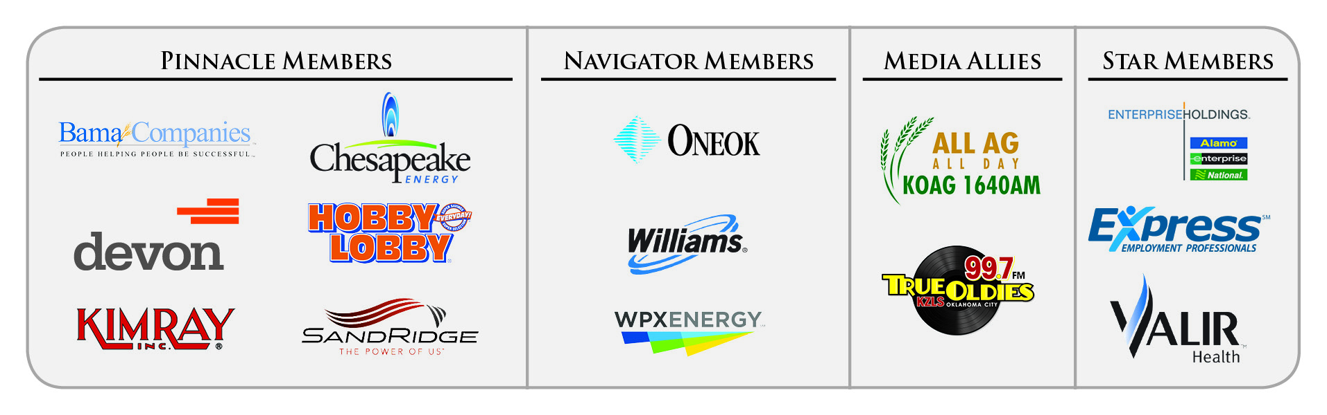
Special Initiatives:
Michael | Mount | Oklahoma Accountancy Board | CPE's
Susan | Pate | Stinnett & Associates | Accountant
Jamie | Potter | Eide Bailly LLC | Facilities & Logistics Chair
Jalisha | Petties | OK Ethics | Member Care Coordinator
Anna | Rosenthal | OK Ethics | Special Projects & Name Tags
Connie | Root | Walker Companies | Speaker Gifts
Shirley | Mears | Champlin Broadcasting | Announcements on Morning Drive (99.7)

TUNE IN! Our own Bob Byrne and Shirley Mears featured on the morning drive for True Oldies Channel FM 99.7 – Tune in between 7:00 and 8:00 a.m. to learn more about Oklahoma’s legacy! Also, hear interviews with speakers thanks to Champlin Broadcasting and the folks with the Oklahoma Heritage Association who provide the research for our historic profiles!
DID YOU KNOW?
OK Ethics’ outreach to university students has greatly increased. Part of your membership dues are earmarked to sponsor student ethics activities on thirteen Oklahoma campuses and our Foundation sponsored a Statewide Educators Ethics Symposium that was attended by approximately 70 academic leaders representing nearly 20 educational institutions.
We are extremely proud of our winning student teams from the Regional Ethics Bowl in San Antonio! Oklahoma Christian (1rst & 3rd places), The University of Oklahoma (2nd place) and Oklahoma City University (4th place) will participate in the upcoming national event!

- Upcoming Events: Tulsa Chapter

Thursday, February 21  Doubletree Hotel – Downtown Tulsa | Thursday - March 28  Doubletree Hotel – Downtown Tulsa
“How to Build a Winning Organization”  Presented by  Brad Frank,  President of  Tulsa Tube Bending  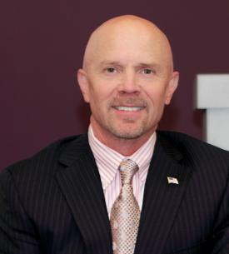 | 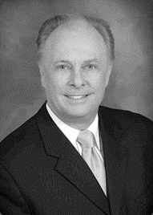  “ReLaunch”  Dr. Mark Rutland  President,  Oral Roberts University

OKLAHOMA BUSINESS ETHICS CONSORTIUM ~ www.okethics.org

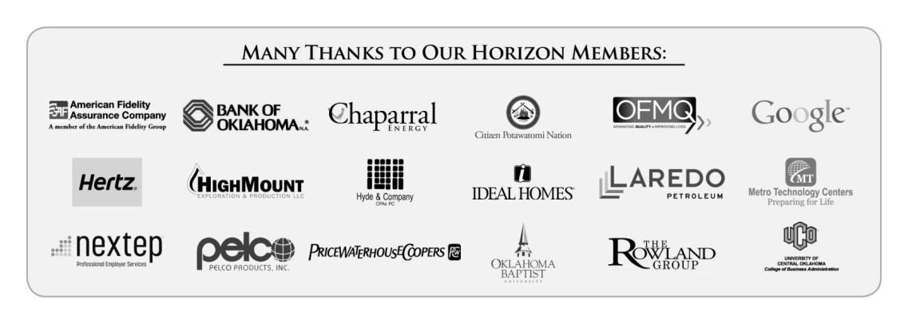
Upcoming Events: Oklahoma City Chapter
Friday, March 1, 2012  Devon Energy Tower - OKC | Thursday, March 7  Petroleum Club – OKC | Wednesday, April 17  Petroleum Club - OKC
BEST PRACTICES  WORKSHOP    Learn from previous award winners and current  Compass Award judges  Carla Brockman,  Devon Energy  and Gary Huneryager  of OGE Energy.  9:00 – 11:00 a.m.  Devon Energy Tower  Must register online – seating is VERY limited.  First come, first served.  Workshop highlights:  - Shared BEST PRACTICES  - BENEFITS of Compass Award application process  - HOW TO OBJECTIVELY MEASURE THE EFFECTIVENESS OF YOUR ETHICS INITIATIVES vis-à-vis Malcolm Baldrige Criteria. |   Dr. Marilyn Tam  Former CEO of Aveda,  President of Reebok Apparel &  Vice President of Nike  “Purpose + Integrity = Happiness”  Born in Hong Kong, this author, entrepreneur and expert on happiness overcame an abusive childhood. She traveled to  the U. S. where she has built and led several companies.  Dr. Tam is listed as one of the four most prominent names  in Ethical Business.  Recommended for 1 CPE in Ethics | 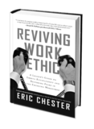  “Reviving Work Ethic in an Age of Entitlements”  Value Added: Developing People from the Inside Out  Research proves that most business leaders are not satisfied with the performance, productivity, and the service they are getting from their emerging workforce. The problem is not so much a skills gap as it is a values gap. Learn the 7 essential work ethic values within your people to ensure their success, and the success and sustainability of your business.  Presented by Award Winning Keynote Speaker and Bestselling Business Author, Eric Chester  Recommended for 1 CPE in Ethics

Programs Focused on Integrity - (Not affiliated with OK Ethics)

Since the beginning, OK Ethics members have been inspired by our friendship with Character First. Leaders with this organization provided the wisdom and insight for OK Ethic's Guiding Principles. Go to www.characterfirst.com to learn more about tools to help you integrate character and ethics into your organizational culture, or contact John Burnett at 405-815-0001
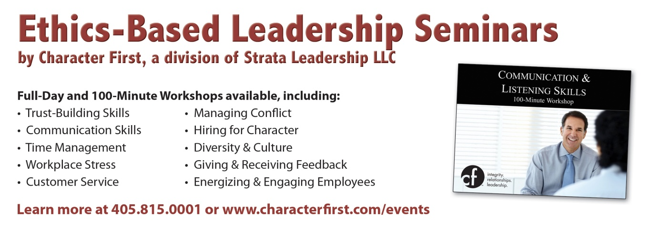

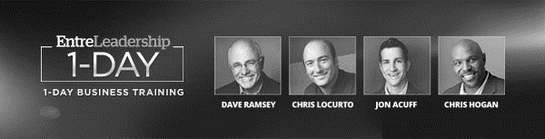
Discounts for OK Ethics Members
See Dave LIVE in OKC on Friday, 04.19.2013
along with best-selling author Jon Acuff
Dave Ramsey is bringing his event, EntreLeadership 1-Day, for leaders and entrepreneurs to the Cox Convention Center in Oklahoma City. This 1-day event is based on Dave’s New York Times #1 best-seller, EntreLeadership. At this event, Dave and his guests will show you how lead with excellence, and they have set up a discount code for OK Ethics members. They have created a Coupon Code code to give you discounted general admission seats for only $99 flat while they last.
Watch for the next OK Ethics meeting notice for the special link to obtain this discount!
REMINDER: PLEASE PICK UP CPE’S
AT CONCLUSION OF EVENT.


“Overcoming Cultural Barriers to Integrity”

presented by

Lori Tansey Martens

President & Founder,
International Business Ethics Institute
Washington D.C.

Program Description:
Ever have trouble explaining something that you believe is morally important to someone who doesn't understand? It is possible that they may be as frustrated as you are. Cultural influences, whether due to regional customs, religious beliefs, traditions or societal factors, can create barriers in working together to find the right path to follow.

In addition, Ms. Martens will be discussing the importance of going beyond what is typically known in companies as compliance toward understanding the spirit behind corporate ethics policies.

Recommended for 1 CPE in Ethics at the basic level. Program is suitable for any business leader desiring to learn more about international ethics and promote integrity in the workplace.
Recommended for 1 CPE in Ethics

About the presenter:
Lori Tansey Martens is a leading authority on international business ethics and has been recognized as a contemporary American opinion leader. Active in the field of business ethics for almost 20 years, Ms. Tansey Martens frequently travels the world over speaking on matters of business ethics and has been quoted in publications including the New York Times, Guardian, Investor’s Business Daily, USA Today, and Business Ethics Magazine. She has also appeared on such news broadcasts as CNN's Lou Dobbs Tonight, the Nightly Business Report, and CNN Financial News. She has conducted ethics training programs throughout the world, including Africa, the Asia Pacific, Eastern and Western Europe, and Latin and North America.

As founder and chief executive officer of the International Business Ethics Institute, Ms. Tansey Martens is responsible for overall management of the organization. Her primary responsibilities include managing and directing the Institute's research and educational activities designed to promote responsible international business practices. Additionally, she advises corporate CEOs and Ethics and Compliance Officers on policies and management systems to promote improved ethical standards, and oversees organizational assessments and senior level ethics education and training.

Previously, Ms. Tansey Martens served as Director of Advisory Services and Executive Director at the Ethics Resource Center. While at the Ethics Resource Center, Ms. Tansey Martens conceived of and launched the first National Business Ethics Survey which has since become the leading benchmark survey in the field of ethics today.

Ms. Tansey Martens began her professional career in Procter & Gamble's highly regarded brand management organization. While at Procter & Gamble, she supervised product lines totaling over U.S. $100 million, developed one of the highest scoring new product concepts in the company's history, and participated in the development of an award-winning national advertising campaign. She led interdisciplinary teams composed of Research and Development, Finance, Sales, Engineering, and Manufacturing.

Ms. Tansey Martens graduated cum laude in Political Science with a concentration in International Relations from Duke University. She is also a graduate of the European Community Law Program at King's College, London, England.

Overcoming Cultural Barriers to Integrity
- About the Institute (www.business-ethics.org)
  - Private nonprofit educational organization
  - Activities include:
    - Advising and consulting MNCs on global business ethics programs and issues
    - Public education
    - Research studies
- Understanding Culture
Culture is more often a source of conflict than of synergy. Cultural differences are a nuisance at best and often a disaster.
- Prof. Geert Hofstede, Emeritus Professor, Maastricht University
- The Challenge of Culture
- Culture is “mental programming”
- In business ethics, cross cultural conflicts tend to arise in the following:
  - Cultural myopia
  - Importance of relationships vs. rules
  - Privacy and personal life
  - Individualism vs. community (Hofstede)
  - Power Distance (Hofstede)
- International Standards
- More than 100 sets of international standards/guidelines
- Top 5 identified as most influential:
  - ISO 14000
  - Global Reporting Initiative
  - World Business Council for Sustainable Dev.
  - ILO Core Conventions
  - UN Global Compact
- Geography Dependant

OKLAHOMA BUSINESS ETHICS CONSORTIUM ~ www.okethics.org

What Should You Do?
Your company is negotiating a large and a strategically important contract in an international market. Your local contact has suggested that one of your representatives, a young African-American female, should not be seen by the customer. The suggestion is based on local prejudices of gender, race and age. Should you send a different representative? What should you do?
What Should You Do?
A very important prospective customer in the Middle East had given your Sales Director a very expensive watch. The Director had accepted the watch and then turned it over to the company, per company policy. Your company then donated the watch to a charity auction. When the Director later called the customer in preparation for his next visit to the region, the customer asked the Director how he liked the watch and mentioned that he looked forward to seeing it when they next met. What should you do?

What Should You Do?
A despotic ruler has requested a political contribution from your company’s local offices. To refuse could put your local senior managers at risk of physical harm, injury or even death. What should you do?
- Ethics vs. Compliance Cultures
It is not an adequate ethical standard to aspire to get through the day without being indicted.
-- Former SEC Chairman Richard Breeden
Ethics: Tthe study of morals in human conduct; moral philosophy
Compliance: Obedience to a request, command, etc; the capacity to yield under an applied force. - Oxford English Dictionary
- Reasons for Shift to Compliance
- Overwhelming increase in legislative actions affecting business
- Legal rationales are easier to “sell” to management to gain resources, attention
- Increase in number of lawyers in the field
- Compliance risks to organization perceived as greater than “ethics” risks
- Are You Building an Ethics or Compliance Culture?
Compliance
- Uses fear to motivate
- “Trains”
- Focuses on laws
- Tries to eliminate decision-making
Ethics and Integrity
- Inspires and motivates
- “Educates”
- Focuses on fairness, honesty and responsibility
- Informs decision-making

- Summary
  - Be open to cultural differences
  - Determine which corporate standards and values are sacrosanct, and which can allow for cultural sensitivity
  - Often a focus on business-based rationales is better than abstract appeals to ‘ethics’
  - Create an ethics culture, not just compliance

Interested in Receiving OK Ethics Monthly Meeting Notices?

OKC:
Contact Jalisha Petties, Member Care Coordinator
at (405) 889-0498 or via email okethics@yahoo.com

Interested in joining OK Ethics?
Contact Lynda Mobley, Vice President of Membership; Lynda.Mobley@oneok.com

LIKE OK ETHICS ON FACEBOOK


General Program Disclaimer:
Members of the Oklahoma Business Ethics Consortium frequently share information concerning various issues and developments that may have legal implications. The discussions, commentary, and handouts at Consortium meetings or presentations to other organizations are for general informational purposes only. They cover only some aspects of the subject topic, and do not constitute a complete legal analysis of the topic or how it might apply to any particular set of facts. Before taking any action based on information presented during a Consortium event, participants are encouraged to consult a qualified attorney. The observations and comments of presenters at Consortium meetings and networking are the views and opinions of the presenter and do not constitute the opinion or policies of the Consortium or any of its members. Presenters are respectfully requested to avoid profanity, preaching, politics, put-downs and self-promotion during their lectures
OKLAHOMA BUSINESS ETHICS CONSORTIUM ~ www.okethics.org

Oklahoma Business Ethics Consortium Guiding Principles
Adopted July, 2004
To ensure that the Consortium fosters positive characteristics of integrity in the successful achievement of its goals, these Guiding Principles were discussed and adopted (with revisions) during a milestone planning session held by Consortium leaders in Stroud on June 18, 2004. These principles were developed based on the Character First's values and philosophies.
I. Responsibility to Self and Others:
- Service:
  - Passion for promoting ethics and integrity
  - Encouraging the promotion of ethical behavior through personal actions and
  - Sharing ideas and resources
  - Responsibility and accountability for fulfilling the mission of the Consortium.
- Collaboration:
  - Achievement of common goals through the promotion of ethical, mutually beneficial relationships
  - Service to the Consortium over promotion of self-interest
  - Cooperation emphasized over competition in promoting ethical business conduct
  - Members collaborate by being constructively engaged in discussions regarding ethics
  - Seeking consensus in interactive discussions regarding ethical matters.
- Respect:
  - Members may become aware of confidential information shared by others in an effort to determine an ethical course of action. We ask members to be sensitive in recognizing and respecting the efforts made toward achieving ethical behavior. In that vein, public disclosure of this information is discouraged.
  - We respect other members and the process by:
    - Exhibiting listening skills and actively listening to discussions
    - Being open to other points of view and outcomes
  - We are an inclusive organization and demonstrate this by welcoming members who are in different stages of learning as applied to ethical behavior.
II. Lead with Integrity
- Dependability:
  - Members are asked to demonstrate their support of this initiative by consistently attending meetings.
- Initiative:
  - Recruiting other members who have demonstrated a desire to promote ethical behavior in their organizations.
  - Recognizing what needs to be done to help promote the Mission of the Consortium and taking action to assist in that effort.
- Honor:
  - Members are asked to honor the Consortium through the practice of integrity and ethical behavior in their business dealings.
  - We express gratefulness to our hosts, sponsors and speakers; as well as to those whose volunteer service makes OK Ethics a stronger organization.
  - Realizing that each of us is in a mode of continual learning, we demonstrate humility, care and compassion when sharing our thoughts and knowledge.
- Courage:
  - Speak the truth with confidence and encourage others to do the same.
III. Inspire Trust
- We serve and promote the cause of truth with integrity, objectivity and fairness to all persons.
  - We hold ourselves accountable by consistently honoring our word.
  - We extend trust abundantly to those who have earned it.
  - Trust, once earned, will not be taken for granted, manipulated or abused.

